JPG (JPEG)

📘 Definition
# Source: AI Source: Provided by: [Data Path: Persons Table -> ID Column: 1, Name_En Column: Motasem Essam] -> From: [ChatGPT] on [5/2/2026]
JPG (or JPEG – Joint Photographic Experts Group) is a popular image file format used to store digital photographs with compressed file size.
It reduces file size by slightly reducing image quality, making it easy to store and share images.

📸 How JPG works
# Source: AI Source: Provided by: [Data Path: Persons Table -> ID Column: 1, Name_En Column: Motasem Essam] -> From: [ChatGPT] on [5/2/2026]
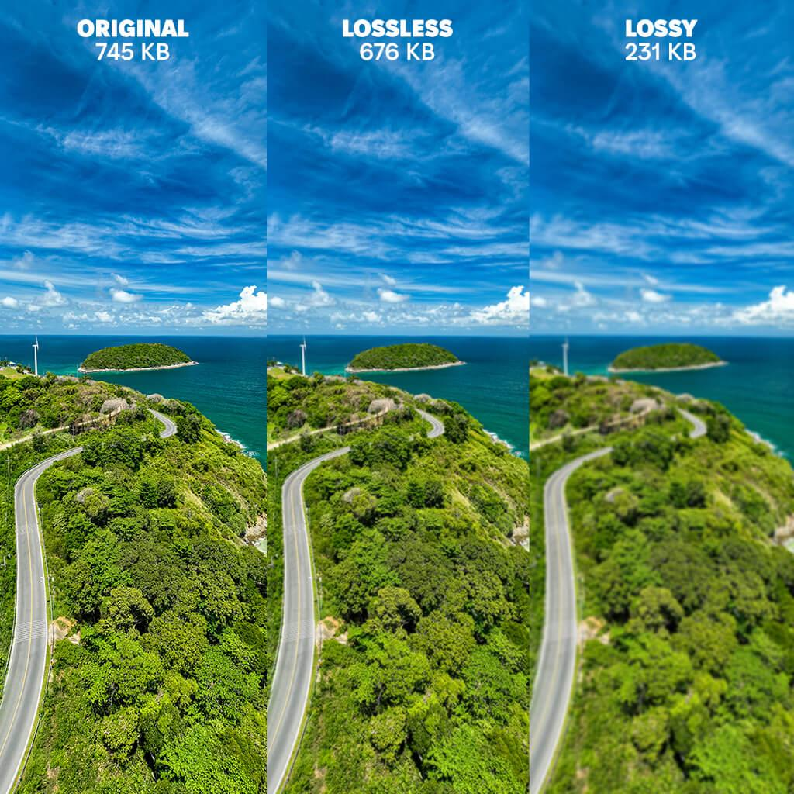
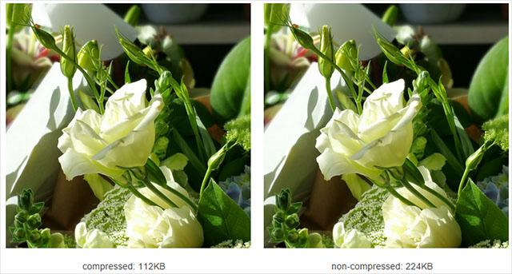
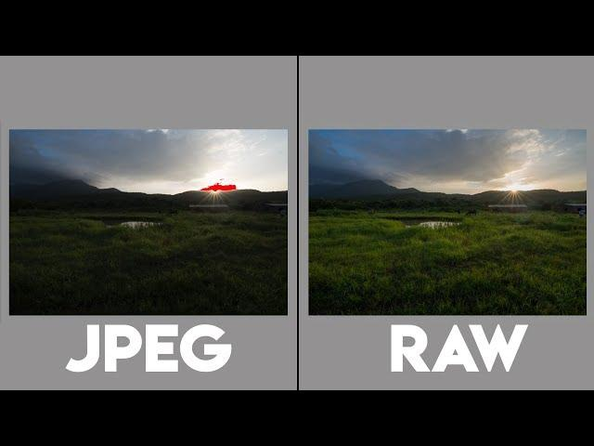
- JPG compresses images to reduce file size
- Some image details are removed (lossy compression)
- Best for real-world photos
- Keeps images small and easy to share

🧠 Simple example
# Source: AI Source: Provided by: [Data Path: Persons Table -> ID Column: 1, Name_En Column: Motasem Essam] -> From: [ChatGPT] on [5/2/2026]
Think of:
- 📱 A photo on your phone gallery
- 🌄 A landscape picture you download from the internet
- 📧 An image sent through email or WhatsApp
Most of these are JPG files.

🎮 Where JPG is used
# Source: AI Source: Provided by: [Data Path: Persons Table -> ID Column: 1, Name_En Column: Motasem Essam] -> From: [ChatGPT] on [5/2/2026]
- 📸 Digital photography
- 🌐 Websites and social media
- 📧 Email attachments
- 🖨️ Online image sharing and printing

⚙️ Key features
# Source: AI Source: Provided by: [Data Path: Persons Table -> ID Column: 1, Name_En Column: Motasem Essam] -> From: [ChatGPT] on [5/2/2026]
- 📉 Small file size (compressed)
- 🎨 Good for photographs and realistic images
- ⚠️ Loses some quality when compressed
- 🖼️ Based on raster (pixel) images

🚀 In short:
# Source: AI Source: Provided by: [Data Path: Persons Table -> ID Column: 1, Name_En Column: Motasem Essam] -> From: [ChatGPT] on [5/2/2026]
JPG = a compressed image format used mainly for photographs to reduce file size while keeping good visual quality.

